**Hotel grand inn**

**Room choice**

**PER DAY BASIS**

* **SINGLE @800**
* **DOUBLE @1200**
* **QUEEN @1500**
* **SUITE @2000**
* **PRESIDENTIAL @2800**
* **CABANA @3500**

**NOTE:**

* All room timings start @10am
* Special discount for occasions and parties

**Single:** A room assigned to one person. May have one or more beds.

The room size or area of [Single](https://setupmyhotel.com/homepage/hotel-management-glossary/single.html) Rooms are generally between 37 m² to 45 m².

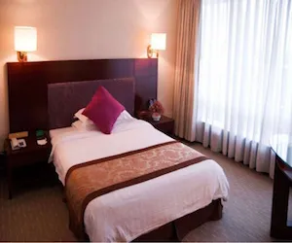

**Double:** A room assigned to two people. May have one or more beds.

The room size or area of [Double](https://setupmyhotel.com/homepage/hotel-management-glossary/double.html) Rooms are generally between 40 m² to 45 m².

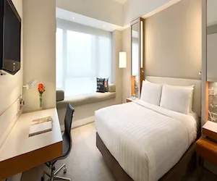

**Queen:** A room with a queen-sized bed. May be [occupied](https://setupmyhotel.com/homepage/hotel-management-glossary/occupied.html) by one or more people.

The room size or area of [Queen](https://setupmyhotel.com/homepage/hotel-management-glossary/queen-bed.html) Rooms are generally between 32 m² to 50 m².

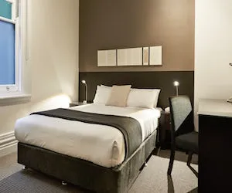

**Suite / Executive Suite:**A parlour or living room connected with to one or more bedrooms. (A room with one or more bedrooms and a separate living space.)

The room size or area of [Suite](https://setupmyhotel.com/homepage/hotel-management-glossary/suite.html) rooms are generally between 70 m² to 100 m².

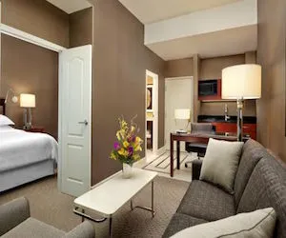

**President Suite | Presidential Suite:** The most expensive room provided by a hotel. Usually, only one president suite is available in one single hotel property. Similar to the normal suites, a president suite always has one or more bedrooms and a living space with a strong emphasis on grand in-room [decoration](https://setupmyhotel.com/homepage/hotel-management-glossary/decoration.html), high-quality [amenities](https://setupmyhotel.com/homepage/hotel-management-glossary/amenities.html) and supplies, and tailor-made services (e.g. personal butler during the stay).

The room size or area of Presidential Suites are generally between 80 m² to 350 m².

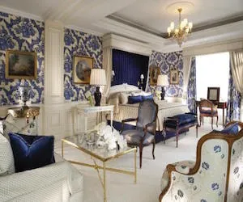

**Cabana:** This type of room is always adjoining to the swimming pool or have a private pool attached to the room.

The room size or area of [Cabana](https://setupmyhotel.com/homepage/hotel-management-glossary/cabana.html) Room Types are generally between 30 m² to 45 m².

